**Utilizing HUBzero to Create and Test an Educational Hub from CReSIS Educational Data**

by

JUSTIN M DELOATCH

A Thesis submitted to the Graduate Faculty of

Elizabeth City State University

In partial fulfillment of the

requirements for the Degree of

Master of Science in Mathematics

Elizabeth City, North Carolina

May

2014

APPROVED BY

__________________________________________________  
Linda Hayden Ph.D  
Chair of Thesis Committee

Geoffrey Fox Ph.D  
Committee Member

Malcolm LeCompte Ph.D  
Committee MemberYolanda Anderson Ph.D  
Committee Member

Copyright by

JUSTIN M DELOATCH

May 2014

**Utilizing HUBzero to create and test an Educational Hub from CReSIS Educational Data**

The PolarEDHub that is housed at Elizabeth City State University (ECSU) is created with the software package named HUBzero. The importance of the PolarEDHub is that it allows K-12 educators to teach students and to motivate them to become more involved in STEM related fields. HUBzero is an open source software package used to construct web sites for scientific research and educational activities. HUBzero was originally created by researchers at Indiana University – Purdue University Indianapolis (IUPUI) in conjunction with the National Science Foundation (NSF) who sponsored the Network for Computational Nanotechnology to support nanoHUB.org. The HUBzero platform currently supports over 40 hubs across a variety of disciplines, including cancer research, biofuels, climate modeling, water quality, and education.

This project utilized data from the Center for Remote Sensing of Ice Sheets (CReSIS), which was established by the NSF as a Science and Technology Center in 2005. CReSIS has a mission of developing new technologies and computer models to measure and predict the response of sea level change to the mass balance of ice sheets in Greenland and Antarctica. [5] Their website offers enormous amounts of ice sheet data that includes thickness, dates, latitudes and longitudes of each ice sheet. The website also offers educational data sets which this project has utilized.

The goal of the project was to create and test the PolarEDHub that has the ability to access CReSIS educational data that has been stored on a server on the campus of Elizabeth City State University (ECSU). This Hub will allow students and educators to have access to this information for the use of education and scientific collaboration. HUBzero requires that the administer uses Joomla, HTML, CSS and PHP code to create the template. HUBzero also uses an application called Raptture to create a Graphical User Interface (GUI) that is capable of deploying new tools without having to rewrite special code for the web. Tools in the PolarEDHub have been created to be interactive, which means it is capable of zooming in on a graph, rotating a module, and probing surfaces of a 3D volume, without having to download the application to the client’s computer. Due to the fact that HUBzero supports Grid Data management, it is capable of sending jobs off to TeraGrid, DiaGrid, and RedCloud to process the data faster and more efficiently. This PolarEDHub is the first science gateway implemented at Elizabeth City State University that is intended for use by the public.

# Acknowledgments

I would like to thank Dr. Geoffrey Fox, professor of Computer Science, Informatics, and Physics at Indiana University and director of the Community Grids Laboratory of the Pervasive Technology Laboratories from Indiana University for his support and guidance in this project. Data was provided by the Center for the Remote Sensing of Ice Sheets from the University of Kansas. I would also like to thank Dr. Linda Hayden, Director of the Center of Excellence in Remote Sensing and Research at Elizabeth City State University, for the mentorship and guidance during the past six years. I would like to thank Dr. Yolanda Anderson, in the Mathematics and Computer Science department for her leadership and assistance. I would like to thank Dr. Malcolm LeCompte, for the great advice and mentorship. I would like to thank Mr. Jeff Wood for his support throughout this project. This project has been funded by the National Science Foundation award 1216668, CReSIS award number FY2005-108CMI and AaA REU Site program under Grants No. ANT-0944255 and PLR-1263061.

# Table of Contents

Page

Acknowledgments 5

Table of Contents 6

List of Figures 10

Chapter 1 Introduction 11

Background 11

Ice Sheet Research 11

What is HUBzero 15

The Value of Education 17

Center for the Remote Sensing of Ice Sheets (CReSIS) 18

Polar Grid 19

Indiana University 20

Center of Excellence in Remote Sensing Education and Research 21

Statement of Purpose 21

Definitions 22

HTML 22

Joomla 23

Cascading Style Sheets 23

PHP: Hypertext Preprocessor 24

Research Overview 24

Chapter II Literature Review 26

Background 26

SDCI NMI Improvement 27

Using the HUBzero Platform 27

How does a Hub differ from a web site? 28

Features 28

Interactive Simulation Tools 28

Mechanism for Uploading New Resources 29

Tool Development Area 30

Ratings and Citations 30

Content Tagging 30

Usage Statistics 31

News, Events and Feedback 31

HUBzero Projects 31

First Hub Focused on Nanotechnology 32

Network for Earthquake Engineering Simulation (NEES) 32

Accelerating in Healthcare 33

Chapter III Methodology 35

Definition of Goal: Original Tasking 35

Project Data Source 36

Installing HubZero 37

Registering as a User 40

Uploading CReSIS Educational Data to SSH Drive 41

Customizing the Hub 42

Articles 44

Header Section: Opening Lines 44

Creating a Section 45

1st Section 45

2nd Section 45

3rd Section 46

4th Section 46

Ending Sections 47

Templates 47

Database 1.1.2 48

Database 1.2 50

Creating an Excel File 50

Chapter IV Results 52

Overview 52

Visual 52

Connecting the Database to the Server using PHP 53

Mobility of the Hub 56

Testing the PolarEDHub 56

Users Feedback 57

Chapter V Discussion 59

Introduction 59

Discussion 59

Limitations 60

Recommendations for Future Research 60

Conclusions 61

Bibliography 62

Appendix A – Code from “Congratulations Article” and “openfile.php” 65

# List of Figures

Figure 1: Greenland Ice Sheet Data 15

Figure 2: HUBzero logo 16

Figure 3: Education Image and Developmental Research 18

Figure 4: PolarGrid Elements 21

Figure 5: Image of VMware installing HUBzero 39

Figure 6: Setting VMware to run host only mode 40

Figure 7: Using the commands “ifconfig eth0” and “nano /etc/hosts” 41

Figure 8: Uploading Educational Data Using FileZilla 43

Figure 9: Image of the Back-End 44

Figure 11: Utilizing the Congratulations Article to change content on the Front-End 45

Figure 12: Basic template from new hub 49

Figure 13: Article in Joomla to replace the database 50

Figure 16: CSV file 55

Figure 17: Database 56

Figure 18: Image of survey 58

# Chapter 1 Introduction

## Background

Whether it consists of simulating and analyzing ice sheet data, replicating the formation of hurricanes, using geospatial science to anticipate the spread of fire in a forest or sharing valuable data to other universities and institutions, the boundaries for science continue to expand each day. (Bartlett, 2005) Today, scientists and researchers are searching for new ways of sharing, analyzing, and visualizing large and complex amounts of data so they have turned to portals and science gateways. Imagine the existence of science gateways and the sophisticated cyber infrastructure (CI) tools organized together with an Internet connection to create a powerful open source software that is capable of solving the most difficult challenges for scientists and researchers.

## Ice Sheet Research

An ice sheet is defined as a mass of glacial ice covering more than 20,000 square miles. There are two known ice sheets on Earth; these cover most of Greenland and Antarctica. Together, the ice sheets of Antarctic and Greenland contain more than 99% of the freshwater ice on the planet. These ice sheets contain massive amounts of frozen water and if melted could cause a number of problems for all of us. If the Greenland Ice Sheet melted, scientists estimate that the sea level would rise about 20 feet, which would be a problem for low land areas. However, according to scientist, if the ice sheets of Antarctic melted, the sea level would rise by about 200 feet, which would do critical damage to many more people and geography than anyone could imagine. (Brain, 2011) This would mean massive problems and destruction for most of the planet. The melting of these ice sheets would also influence weather and climate change.

Greenland’s Ice Sheet has already begun to deteriorate as indicated by scientific research. From 1979 to 2006, melting increased by 30 percent, which reached a record high. At higher elevations, a growth in winter snow has offset the melting. However, the decline continues to surpass accumulation because of warmer temperatures that have led to increased melting and speedier glacier movement. (Brain, 2011)

Global warming and climate change also increases the earth's atmospheric temperature. Which causes equivalent changes in the climate and that causes a greenhouse effect. The drastic melting of the ice sheets in Greenland and Antarctica has scientists examining questions and answers for proof of glacial retreat.

Scientists are always looking for different ways to model and measure the response of ice sheet changes due to global warming. These extremely technical needs can be fulfilled by scientific collaborations between research institutions. There is also a huge need to gather acquired data and, within the position of educators and researchers in a collective effort, educate the next generation of scientists to study this complex issue. (Brain, 2011)

Much of ice sheet research is currently being accomplished by allowing the data to be obtained in the field via the Internet education between university faculty and the public. Once this data is processed it should be available for research experiment by undergraduate and graduate students. This form of distribution would allow for more science, technology, engineering and mathematics (STEM) related majors to access experimental data that will increase their knowledge and persuade students to become scientists. This method of distribution allows students studying under STEM umbrella a greater range of student access to real-world data. This gives students increasing knowledge experience and persuades them to pursue a field directly related to the STEM fields.(Brain, 2011)

Below in Figure 1: NASA says new satellite measurements indicate extraordinary Greenland ice sheet surface melt. The images posted below show the degree of surface melt over Greenland’s ice sheet over just a four-day period. This period was from July 8, 2012 (left) and July 12, 2012 (right). These measurements were from three satellites that showed that on July 8, about 40% of the ice sheet had experienced melting. Melting severely quickened to an estimated 97% of the ice sheet surface by July 12. On an average summer, about half of Greenland's surface ice sheet naturally melts. Lora Koenig, a Goddard glaciologist and a member of the research team analyzing the satellite data, says, "Ice cores from Summit show that melting events of this type occur about once every 150 years on average. With the last one happening in 1889, this event is right on time. But if we continue to observe melting events like this in upcoming years, it will be worrisome." (DiGirolamo, 2012)

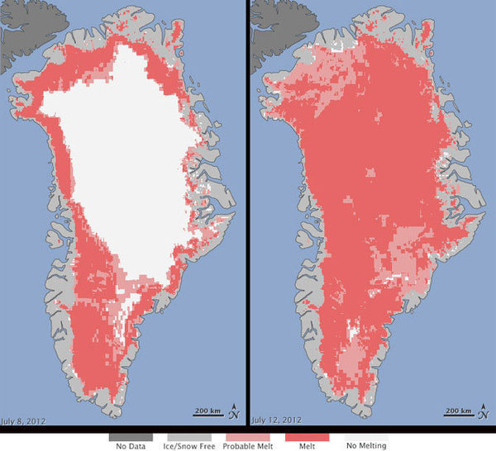

Figure 1: Greenland Ice Sheet Data

## What is HUBzero

## Macintosh HD:Users:Justin:Desktop:hubzero-logo.png

Figure 2: HUBzero logo

HUBzero is a powerful, open source software platform for creating dynamic web sites that support scientific research, educational activities and training. (hubzero) Originally developed for nanoHUB for a resource of Nano science and nanotechnology, nanoHUB.org was created by the NSF-funded Network for Computational Nanotechnology. Such websites are mostly referred to as “collaboratories” supporting team science.

HUBzero calls these advance websites produced from the open-source software hubs because the sites become a crucial contact for user communities. Today, hubs serve virtual communities in health care, engineering education, microelectromechanical systems, volcanology, research ethics, environmental modeling and biofuels, and many other important topics. (hubzero)

A major HUBzero feature is its ability to deploy computational research codes, visualize and analyze results, all through a single web browser. Even when it comes to posting tools, it goes through an automated system, which makes it easier than other tool submitting applications. Additionally, the platform has a growing set of data management tools. HUBzero offers built-in social networking features, the ability to create communities in almost any field and simplify communication and collaboration, distribution of research results, training and education.

Annually the HUBbub conference informed people how to utilize HUBzero in Indianapolis, Indiana. Within the conference there were highlights of a new organization, the HUBzero Foundation, which promises to make HUBzero even more accessible and to expand the platform’s already considerable capabilities. HUBzero offers a foundation to help start up new hubs for researchers that are interested who don’t have the required experience to create their own. The HUBzero Foundation founded by Purdue University in 2010 is open to any academic institution, non-profit organization, or corporation. The HUBzero Foundation offers a number of benefits to members, including access to the latest HUBzero features and bug fixes, a role in setting the roadmap for future development and promoting the use of HUBzero, and ensuring ongoing sustainability of the core software.

HUBzero is a powerful tool that if utilized correctly will benefit the whole community that has access to it. With the use of HUBzero and its resources the hypothesis for this paper is that a hub can be created to house existing data from CReSIS and can visualize this data for the purpose of education, research and scientific collaboration.

## The Value of Education

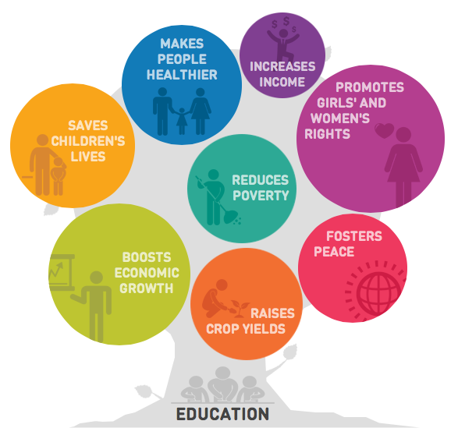

Figure 3: Education Image and Developmental Research

Education is important and a necessity of life. It helps to make people successful and gives them a sense of accomplishment. Perhaps, it is one of the most important things in life because it gives a person the ability to give back and contribute to the world around them. (Schaeffer, 2012) Teaching and sharing knowledge is one of the greatest ways to promote ones subject and to give to those who are interest in the subject. Many people consider knowledge to be power, and having the desire to go an additional step or that extra mile is one of the desirable attributes needed to pursue a career in a STEM field. (Schaeffer, 2012)

STEM learning is an economic essential and a vital part of our world. “Experts say that technological innovations accounted for almost half of U.S. economic growth over the past 50 years. They also conclude that almost all of the 30 fastest-growing occupations in the next decade will require at least some background in STEM.” (Schaeffer, 2012)

STEM programs are cultural achievements that are vital to our humanity and to the control of our economy. These programs embrace and support the necessary aspects of our lives as citizens, teachers, students, parents, and partners in the workforce. Providing students with access to quality education in the STEM disciplines is very important to our nation and the world if we want to keep moving forward in creating new innovative technologies. (Schaeffer, 2012)

## Center for the Remote Sensing of Ice Sheets (CReSIS)

https://www.cresis.ku.edu

The Center for Remote Sensing of Ice Sheets (CReSIS) is a Science and Technology Center established by the National Science Foundation (NSF) in 2005. The mission was developing new technologies and computer models to measure and predict the response of sea level change to the mass balance of ice sheets in Greenland and Antarctica.  The NSF’s Science and Technology Center (STC) program combines the strengths of scientists and engineers to answer the difficulties of global significance and was established in response to the need to study and conduct research in understanding the mass balance of the polar ice sheets. CReSIS uses different types of remote sensing and field observations to support the growth of enhanced technologies and models to measure and forecast the response of ice sheets to climate change. CReSIS is comprised of six partnering institutions with University of Kansas (KU) serving as the lead. Additional partners include Elizabeth City State University (ECSU), Indiana University (IU), The Pennsylvania State University (PSU), University of Washington (UW), and the Association of Computer and Information Science Engineering Departments at Minority Institutions. (ADMI)

## Polar Grid

http://www.polargrid.org

The National Science Foundation Major Research Instrumentation Program (MRI) has funded a combined mission with Elizabeth City State University and Indiana University named PolarGrid, NSF CI-Team Award # OCI-0636361. The partnership goal is to acquire and deploy the computing infrastructure needed to investigate the urgent problems in glacial melting

As shown in Figure 4, PolarGrid support ranges from field camps in Greenland and Antarctica to local educational outreach. Field stations and arranged radar data assembling tools will provide data to base camps and direct the data to mainland processing stations for quality data feedback to field stations.

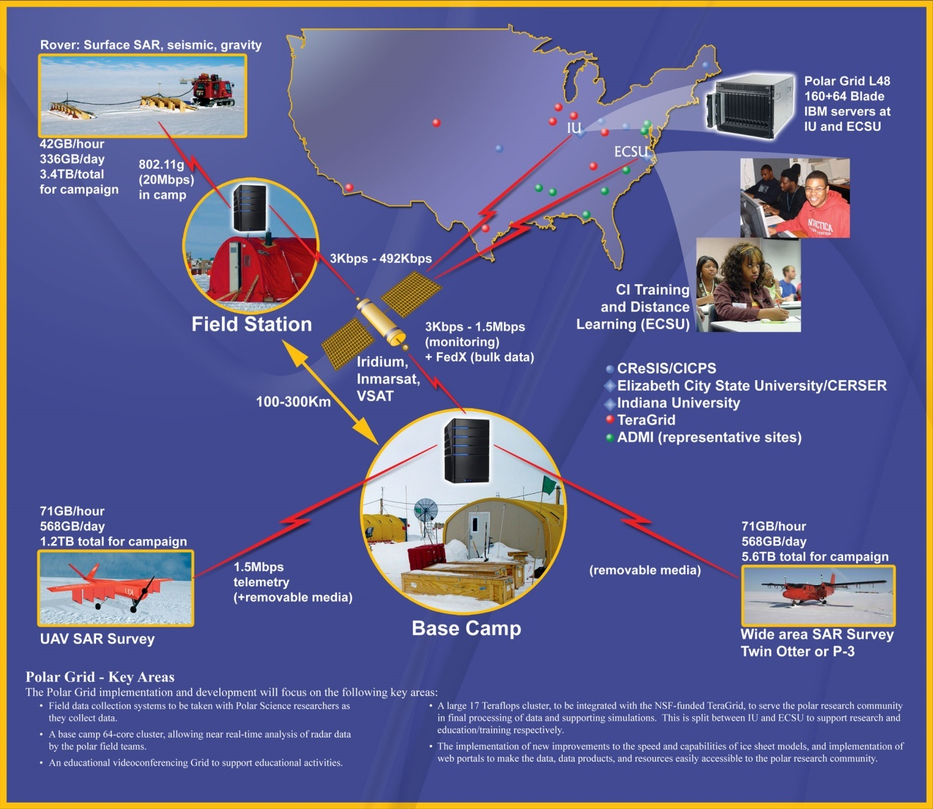

Figure 4: PolarGrid Elements

## Indiana University

http://www.indiana.edu

Cyberinfrastructure (CI) and high-performance computing to focus on the areas of data management, processing, dissemination, archival, and high-performance computer modeling requirements will be sustained by Indiana University (IU). IU has a world-wide reputation for outstanding development of CI research and products. (Gogineni, 2009) IU is a major public research institution, grounded in sciences, and a world leader in technological education. Indiana University has a mission to provide broad access to undergraduate, graduate, and continuing education for students throughout Indiana, the United States, and the world, as well as outstanding academic and cultural programs and student services.

## Center of Excellence in Remote Sensing Education and Research

http://cerser.ecsu.edu

The Center of Excellence in Remote Sensing Education and Research (CERSER) manages research, educational outreach, and student activities in geosciences and remote sensing. Remote sensing is an instrument used to observe the impact of climate change on and below the surface of the Earth. CERSER, under the direction of Dr. Linda Hayden, is a founding partner in the NSF funded Center for Remote Sensing of Ice Sheets (CReSIS) led by The University of Kansas and PolarGrid, an NSF Major Research Instrumentation (MRI) funded partnership with Indiana University (IU). CERSER students have travelled to study ice sheets in Greenland, Scotland, Alaska, and Antarctica. (ECSU Report on Climate Change in NC/Relevant Research at ECSU, 2008) CERSER is located in Elizabeth City, North Carolina on the campus of Elizabeth City State University.

## Statement of Purpose

The reason this project was undertaken was to allow K-12 educators and learners to collaborate together to learn more about ice sheets. Additionally, to motivate the younger generation to become active in a STEM related field. The research question for this paper is: “How can HUBzero be utilized to access a database with CReSIS educational data for the purposes of education, research and scientific collaboration.” This project involves acquiring the educational data from the CReSIS website, storing the information and data on a server and allowing HUBzero to gain access to the server for visualization purposes. The objectives for this project include:

* Installation of HUBzero: This would allow a user to download and install HUBzero on a virtual machine, which can then be utilized.
* Acquiring the Educational Data: This would be to acquire the CReSIS K-12 educational data sets.
* Uploading Data: This step is to allow the educational documents to be accessed by HUBzero.
* Test the resulting product with a sample of K-12 students, educators, or researchers.

## Definitions

### HTML

HyperText Markup Language (HMTL) is the markup language for creating websites and other information that can be displayed within a web browser. HTML is written in a form of elements consisting of tags enclosed in angle brackets such as (<html>). HTML tags are most commonly joined in pairs like <h2> and </h2>, while other tags represent empty elements and so are unpaired, for example <br>. The first tag is called the opening tag, and the second tag is called the closing tag. Between these tags web developers add text, comments and more information to give the website a unique look. (w3schools.com)

The web browser’s job is read the HTML text and compile them into visible web pages. Most importantly the browser does not display the HTML tags, but uses the tags to interpret the content of the page. HTML elements form the building blocks of all websites and allows images to be embedded and can be used to create interactive web sites. (w3schools.com)

### Joomla

Joomla is a free and open-source content management system (CMS) for distributing web content. It is built on a management web application framework that can be used separately from the CMS. Joomla is written in PHP: Hypertext Preprocessor, and uses object-oriented programming (OOP) techniques for software design patterns. It also stores data in a MySQL database, and involves features such as page caching, RSS feeds, news flashes, blogs, polls, and search bars.

### Cascading Style Sheets

Cascading Style Sheets (CSS) is a style sheet language used for designing the look and structuring of a document written in a markup language. While CSS is most commonly used to design web pages and interfaces written in HTML, the language can be applied to any kind of eXtensible Markup Language (XML) document, including plain XML. XML is designed to transport and store data and is designed to carry data, not to display data

CSS is created primarily to allow the parting of content from presentation. The split has improved on the ability to provide more content accessibility and improved more flexibility and control in certain characteristics, which allows multiple pages to share formatting, and reduce complexity.

### PHP: Hypertext Preprocessor

PHP: Hypertext Preprocessor (PHP) is free software released under the PHP License. PHP can be installed on most web servers and as an individual shell on almost every operating system and platform, free of charge.

PHP code is understood by a web server with a PHP processor module, which produces the developing web page. PHP commands can also be embedded directly into an HTML source document rather than referring to an external file to process data.

PHP is a server-side scripting language meant for web development but is also used by many as a general programming language. PHP has been installed on more than 244 million websites and 2.1 million web servers.

## Research Overview

This thesis focuses on confirming the capability of utilizing CReSIS educational data to create a science gateway for K-12 students, educators and researchers who would like to provide educational data to their students.

Chapter 2 focuses on several projects currently utilizing HUBzero as a science gateway. This chapter will also inform readers about the different types of features that make HUBzero a powerful product for research, education, and scientific collaboration.

Chapter 3 presents the in-depth description of the application development and the procedure to implement HUBzero. A step-by-step description of the installation methods and processes will be described here. Once the data is uploaded and downloaded the process and the procedure of the outcome will be described here.

In Chapter 4 the final results of the development process are presented. The actual processes for interacting with the application are explained illustrating how each section of development satisfies a particular target of the overall research question. The conclusion of this chapter exhibits the overall flow of the application from an abstract view. The results of the testing process will also be apart of this chapter along with some graphs and readings to show how the users interacted with the PolarEDHub.

Chapter 5 concludes the thesis with a discussion of the results and their impact on the project as a whole. The chapter also includes a section on the limitations of this project putting forward shortfalls in skill levels, and software capabilities.

Future recommendations for this research would be to find a method of updating the hub every time CReSIS updates their site with more educational data. However, having the ability to make this future proof will need the expertise of those proficient in using Joomla and PHP, and most importantly people that know how to utilize HUBzero in and out. This includes proposals, such as coding changes to the hub to allow the hub to update freely for the ease of the developer and the users. The paper concludes with a discussion of the overall impact of this project and its development.

# Chapter II Literature Review

## Background

STEM has been a powerful appliance of success in the US since World War II.

Presently, American students performances and interest in STEM education are insufficient for the US to uphold its leadership in STEM professions unless the government and various institutions take additional actions to stimulate a new generation of US students regarding STEM careers. Despite the consistent actions taken by the government and various institutions, the US cannot ensure the production of a sufficient number of experts in STEM fields to meet its national needs. The current situation is that the US is largely dependent on the foreign-born STEM workforce. (Hossain & Robinson, 2011)

Starting in October 2002, the National Science Foundation formed the Network for Computational Nanotechnology (NCN), with a mission to create a national resource for theory, modeling, and simulation in nanotechnology, to connect users in research, education and design. The NCN created a cyberinfrastructure embodied by their website, nanoHUB.org. In 2009, nanoHUB.org provided service to over 250,000 visitors from 172 countries worldwide. (G.Klimeck, 2006) Of those, more than 100,000 spent at least 15 minutes on the site viewing seminars, teaching materials, or interacting with simulation tools. The hub offers groups to provide private collaboration, software development projects in nano areas, calendars, and many other features designed to support researchers. Most importantly, nanoHUB.org connects researchers and scientists to the simulations tools they need for successful research. Users can get access to over 170 interactive, graphical tools with visualization and analyzing tools over a regular web browser. (G.Klimeck, 2006)

This literature review will focus on several projects, their tools and how each institution implemented their hub. HUBzero is an open source software and can be deployed on a machine with the right requirements and by a person with the basic knowledge of computer science.

## SDCI NMI Improvement

Volunteer computing is when computer owners donate the use of their processing and storage resources to scientific research projects. This process can supply more computing power to scientist at a lower cost and is already being used in areas such as: medicine, nanotechnology, climate modeling, mathematics, and quantum computing. Currently there are about one million computers (mainly home PCs) that participate in volunteer computing, supplying roughly 10 PetaFLOPS of processing power, which is several times that of the largest supercomputer. (Anderson, 2012)

Few scientists are benefiting from this massive computational resource, which is why SDCI proposes to close the gap by integrating BOINC (Berkeley Open Infrastructure for Network Computing), which is the middleware platform for volunteer computing with HUBzero. This proposed research will take three years to be completed but once completed HUBzero will become so popular and powerful, scientist and researchers will start migrating to HUBzero. (Anderson, 2012)

## Using the HUBzero Platform

The Rosen Center for Advanced Computing (RCAC), the research division of Information Technology at Purdue (IT@P), has help nanoHUB.org develop throughout its existence. RCAC has a solid record for production and quality. In 2009, they maintained more than 50 TeraFlops of high-performance computing equipment and kept nanoHUB.org running with 99.5% uptime. (McLennan M. )

## How does a Hub differ from a web site?

HUBzero is a website built with regular tools that a website uses but HUBzero builds upon the infrastructure to create an environment in which scientists, researches and students can have access to reliable tools and distribution of their information and findings. Tools utilized to create a hub are the same ones to create a website and they are open source packages: Apache web server, PHP web scripting, Joomla content management system, and a MySQL database for storing content and usage statistics. (McLennan M. )

## Features

HUBzero comes default with many features that users might find exploitable. Such features enhance the user’s ability to collaborate with one another for the purposes of research and education. With these collaborative features build into the PolarEDHub, users will be able to explore the hub with ease and quickly become part of the team within this online community. (McLennan M. )

### Interactive Simulation Tools

The main service of a hub is its capability to distribute interactive, graphical simulation tools through a web browser. In a world where researchers utilize portals and cyber-environments, this ability is simply obsolete. HUBzero has access to tools in a hub that are interactive; such as, users can zoom in and out of a graph, rotate a molecule, and analyze isosurfaces of a 3D shape, all without having to refresh the wed page. Researchers can visualize results without having to reserve time on a supercomputer or even wait for a batch job to engage. Users can deploy new tools without having to rewrite codes for the web. (McLennan M. )

The HUBzero substructure includes a tool execution and delivery mechanism based on Virtual Network Computing (VNC). This means any tool that uses a graphical user interface can be installed on the hub and deployed within a few hours. For older tools and codes without a graphical interface, users are able to use the Rappture toolkit that comes with HUBzero to quickly create an interface. The Rappture interface was created to assist users in setting up jobs and visualizing results. These jobs can be sent off to the TeraGrid, the Open Science Grid, and other participating cluster resources. (McLennan M. )

### Mechanism for Uploading New Resources

HUBzero offers a place for users to collaborate together to share information. The way that HUBzero promotes this feature is to encourage all users to upload their own presentations, tool, and other materials on the hub. The HUBzero software includes a self-service area that guides the user through a step by step process. On the first screen, the user inputs a title and an abstract, uploads associated files, then acknowledges a list of contributors for that particular project. The last step would be submitting the resources for posting. The hub is managed by the hub manager who approves all submissions and maintains the system in order to maintain the system’s integrity. Once an item is published, new items automatically appear in the *What’s New* page of the hub. (McLennan M. )

### Tool Development Area

When users upload online presentations or a PDF document, the process is pretty straightforward; however, uploading a tool is a little more complicated. Tools must be created, uploaded, compiled, tested, fixed, complied again, and tested again until the user wants to have it published. Also each hub comes with a companion site for source code development based on the open source package the user selects. Once the tool is published each tool will have its own project area within the Subversion repository for source code control, a ticketing system to track bugs and an area for project documentation. (McLennan M. )

### Ratings and Citations

The hub’s philosophy is not to judge a resource before you actually utilize it; therefore, the hub allows for registered users to post 5 star ratings and comments for each resource. The hub also allows registered users to post citations that reference the resource in the literature, so users can see other work that builds upon the resource. Citations and ratings are combined with web statistics to produce a number from 0 to 10 to measure popularity. As users would image, the resources with the highest ranking appear at the top of the list for searches and lower rankings are harder to come by on the hub. (McLennan M. )

### Content Tagging

Each resource on the hub is categorized by tags. Tags are arbitrary strings defined by the uploader of the content. Tags have associated pages on the hub where its meaning is defined and its resources are listed. For example, the tag “K-12” will help educators and students fine information related to elementary or secondary education. Tags are defined by the contributor and the hub manager and can be added by others after they rate the resource. (McLennan M. )

### Usage Statistics

The hub reports statistics about each individual hub showing the total number of users, hits, simulation jobs launched, and even down to the number of CPU hours used. The hub also reports how many users have accessed a tool, or how many times an online seminar has been viewed and the numbers are combined to provide an overview of interesting categories. For example, users can see how many people access a particular tool, how many are located in the US, and how many are working in education or industry. These are just some of the categories and statistics that can be found on the hub but there are many more categories that can be found on the hub. (McLennan M. )

### News, Events and Feedback

Every hub comes default with a calendar, which allows any registered user to post events. This allows the hub to become a focal point of information for the community. Each hub also has a news area, which allows the hub manager to post short stories that describe the progress being made by users. The hub also offers the user the opportunity to provide feedback. Users can complete the feedback area where users can respond to poll questions or simply offer suggestions and feedback. (McLennan M. )

## HUBzero Projects

HUBzero projects are composed of building blocks from the lessons learned in previous and new technologies and the standards of today. In this section we will look at several projects utilizing Hub technologies, their goals, and their process of implementation.

### First Hub Focused on Nanotechnology

nanoHUB.org

The nanoHUB was created by the NSF-funded NCN. The NCN is a network of universities with a vision to pioneer the development of nanotechnology from science to manufacturing through innovative theory, exploratory simulation, and novel cyberinfrastructure. NCN students, staff, and faculty are developing the nanoHUB science gateway while making use of it in their own research and education. (nanoHUB, 2013) Collaborators and partners across the world have joined the NCN in this effort. The nanoHUB is driven by research themes in:

* Nanoelectronics
* NEMS/Nanofluidics
* Nano-Bio Devices
* Nanophotonics

### Network for Earthquake Engineering Simulation (NEES)

http://nees.org

NEES is a combined national network of 14 experimental facilities, collaborative tools, a centralized data repository, and earthquake simulation software. NEES uses these resources to provide the means for collaboration and discovery in the form of more advanced research based on experimentation and computational simulations. NEES has revolutionized earthquake engineering research and education. Their research has allowed engineers to develop superior and more cost-effective ways of moderating earthquake damage. Their research will also help prevent infrastructure damage from other natural disasters and from terrorism. (A platform for research, collaboration and education, 2013)

### Accelerating in Healthcare

The Clinical and Translational Sciences Institute (CTSI) supports the entire state of Indiana, led by health science schools of Indiana (IU) and Purdue Universities (PU). The CTSI has a mission to:

1. Research: Create accelerated programs and support pilot projects by providing investigators with planned leadership and mentorship to identify, evaluate, and upkeep pilot research at each step of the cycle.
2. Education: Train a new team of researchers by strengthening current programs and forming new ones to educate trainees in the translational sciences.
3. Community: Nurture forceful community engagement by generating novel programs with bidirectional participation such as the Indiana Community Health Engagement Program (CHEP) and pilot programs in Rural and Global Health.
4. Technology: Construct comprehensive research resources and technologies by altering the existing research organization into groundbreaking programs such as the Participant and Clinical Interaction Resources (PCIR), Translational Technology Resources (TTR), and others to facilitate the translation of research.
5. Partnership: Influence the resources of the Indiana community by connecting to a wide array of resources from numerous institutions throughout the state of Indiana. (Institute)

This review has demonstrated HUBzero’s architecture and software, alongside examples of projects starting with nanoHUB.org for the purpose of nanotechnologies, and, more details of hubs in general. The implementation of HUBzero is not a simple undertaking, but is seen as an ever-moving target with constant work to keep up with technology and scientific needs. HUBzero is a very powerful collaborative software that a qualified team can use to perform outstanding operations and can also allow small institutions the opportunity to simply collaborate and share educational data. While the goal of this thesis is to implement HUBzero for K-12 educators, there is a lot to learn from past developmental projects and their process of implementation. In the future there will be much more documentation and references for utilizing HUBzero to the fullest.

# Chapter III Methodology

## Definition of Goal: Original Tasking

At the University of California, San Diego is the lead institution on a NSF planning grant for a Science Gateway Institute. This Science Gateway will offer a variety of services designed at joining many individual groups developing user-friendly, Web-based portals and tools that enable scientific research. These partner institutions include the Texas Advanced Computing Center (TACC) at The University of Texas at Austin; Elizabeth City State University; Indiana University; Purdue University; and the University of Michigan, Ann Arbor. Partner institutions include a one-year, $500,000 conceptualization award; the team has been asked to develop a tactical plan for a far larger Science Gateway Institute as part of the NSF's Software Institutes program; therefore initiating this project. (XSEDE, 2012)

The project target was to create a Hub that has the ability to access CReSIS educational data that has been stored on a server on the campus of ECSU for the main audience of educators and students to learn more about polar education. Within the documents K-12 students and teachers are invited to explore the many learning and teaching resources available from CReSIS K-12 education page. Users can find lesson ideas, maps, images, and updates about the research that is being conducted.

The high-level goals for this project were as follows:

1. Install HubZero and set up
   1. Install virtual machine
   2. Download and install hubzero software 1.1.2
   3. Input the Hubzero image file into the virtual machine
   4. Configure settings
2. Customizing Hub
   1. Getting to know Joomla
   2. Using articles and modules
   3. Using HTML to edit default files
3. Download educational data from CReSIS site
4. Upload data to Drive
   1. Getting to know commands
   2. Using FileZilla
5. Creating Database via HUBzero
   1. Creating a project
   2. Uploading csv
   3. Connecting to the server
6. Connecting Database to Drive
   1. Getting to know php
7. Testing the Ice-Ed Hub
   1. Gathering data for results

## Project Data Source

The CReSIS site offers numerous amounts of educational data such as the many learning and teaching resources available from CReSIS K-12 education page. Users can find lesson ideas, maps, images, and updates about the research the team is doing. Opportunities for talks by scientists and other resources for science teachers can also be found there.

Below is the data that is available on the CReSIS site:

* Ice Ice Baby Curriculum
* Teacher Professional Development
* Book of the Month
* CReSIS in the Classroom
* Polar Links

However, for this project the Ice Ice Baby Curriculum was the only educational data used for the purposes of trial and error. The addition of the remaining data has been added to the future work section.

## Installing HubZero

Most computers today are powerful enough to run full operating systems on top of your main operating system, which means virtual machines are more common place today than before. Virtual machines allow users to run an operating system emulated within another operating system. For this project, HUBzero was installed using a virtual machine called VMware. VMware is the industry-leading virtualization software company, which empowers organizations to innovate and thrive by streamlining IT operations. (VMware, 2013)

After the installation of VMware was complete the next thing is to install HUBzero.(Figure 5) HUBzero, can be installed after the open source software is acquired from http://hubzero.org/download. There were two options to pick from: a 64-BIT VM IMAGE-TAR.GZ and a 64-BIT VM IMAGE-ZIP. The virtual machine images are 64-bit Linux machines created for VMware.

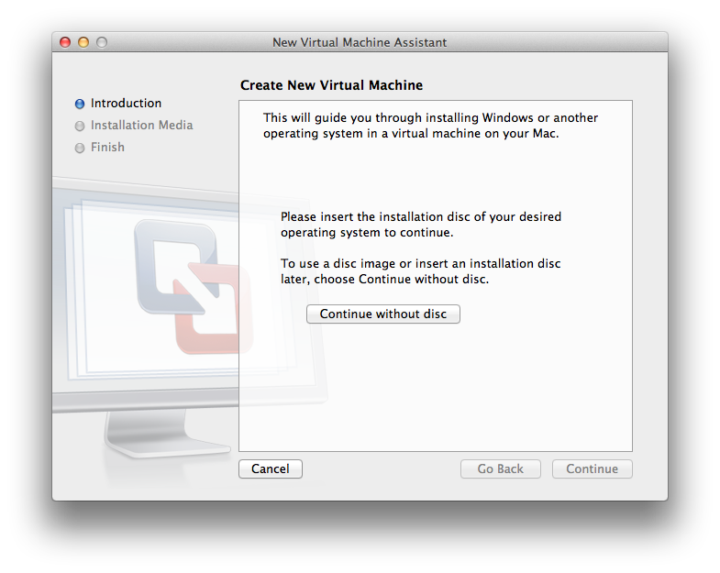

Figure 5: Image of VMware installing HUBzero

Once the installation is completed the next step is to set the Virtual Machine to host only mode. The purpose of setting VMware to host only mode is the VM image contains hard-coded passwords such as “hubzero2012” and is susceptible to attack on the internet. After inputting the passwords the command “ifconfig eth0” was excuted, thus showing the users IP address given to the HUBzero virtual machine by the VMware software. These results are shown in the figures 5 and 6.

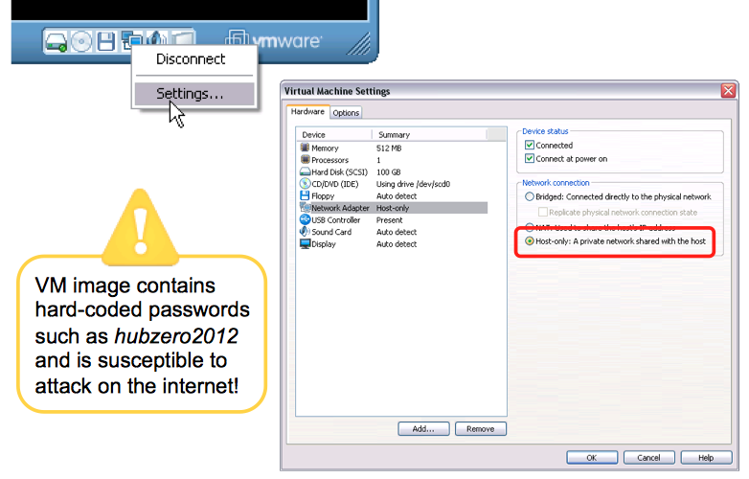

Figure 6: Setting VMware to run host only mode

Once the IP address is noted, the command “nano /etc/hosts” was excuted and the user has to replace the default IP address value with the one noted before. (Figure 7) After this step pressing Ctrl-O, and Ctr-X will exit the editor. The final step was running the “reboot” command, logging back in the VM and double-checking the IP address and making sure it didn’t change. After this step the hub is up and running.

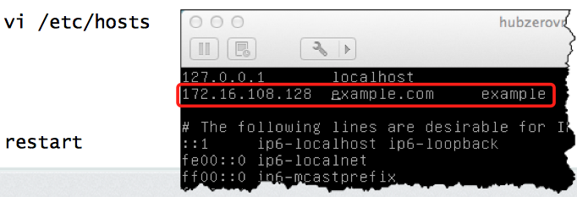

Figure 7: Using the commands “ifconfig eth0” and “nano /etc/hosts”

## Registering as a User

On the homepage of the new hub, which is accessed by the IP address, the “Register” button was pushed in the upper-right corner. This page shows required information that was filled out by the user. Under normal circumstances, an email would have been sent for confirmation from the user. In this case, the VM is set to local-only, therefore the confirmation must be done by the administrator. In order to correct this, the user had to point the browser to http”//XXX.XXX.XXX.XXX/administrator/, where XXX.XXX.XXX.XXX refers to the IP address. The user had to log in with default passwords giving in the documentation. Next the pull down “Users” menu was selected and the “Members” menu was clicked. Next the “Details” button was hit after scrolling down the page, then, “Confirm”, “Email”, then the large “Save” button in the upper-right page was clicked.

## Uploading CReSIS Educational Data to SSH Drive

The CReSIS Educational Data was downloaded from the site https://www.cresis.ku.edu/education/k-12/ice-ice-baby-lessons. Each file was downloaded individually due to the fact there was no easier way to download them all. There were a total of 76 educational documents that were downloaded.

The process of uploading the educational data to the server would have been a very time consuming job. However, the free software FileZilla was utilized for the purpose of uploading the educational documents to the server. FileZilla is a free, open source FTP client, which supports FTP, SFTP, and FTPS . The client is available under many platforms; binaries for Windows, Linux and Mac OS X were available. (FileZilla, 2013)

Utilizing FileZilla was relatively simple. The host name was inputted along with the username, password and port #. After the correct information was inputted FileZilla should make the connections automatically. (Figure 8) Once connected to the server the process of storing the data was just a drag and drop action.

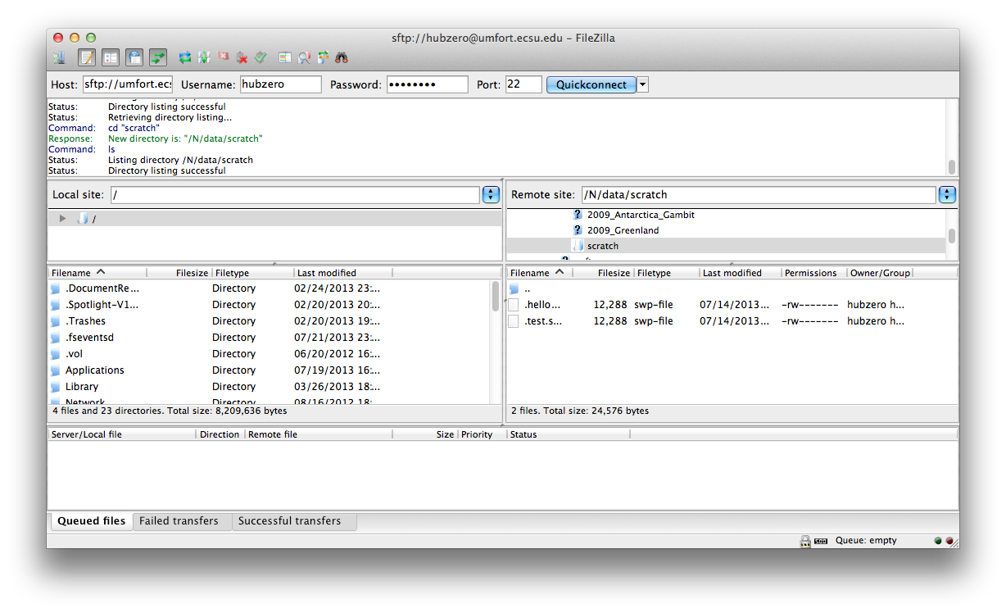

Figure 8: Uploading Educational Data Using FileZilla

## Customizing the Hub

Each new hub requires some configuration and customization based on the needs of the user. Next originates the information about content configuration (article pages), home page configuration (modules, news/announcements, banner), member registration customization (registration options / requirements), and member dashboard customization. (Huebner, 2013) The hub had to be customized by logging into the administrator account. Once logged into the administrators account the Joomla interface was displayed. This gave full access to the “Back-End” in figure 9, which controls the appearances of the “Front-End” in figure 10.

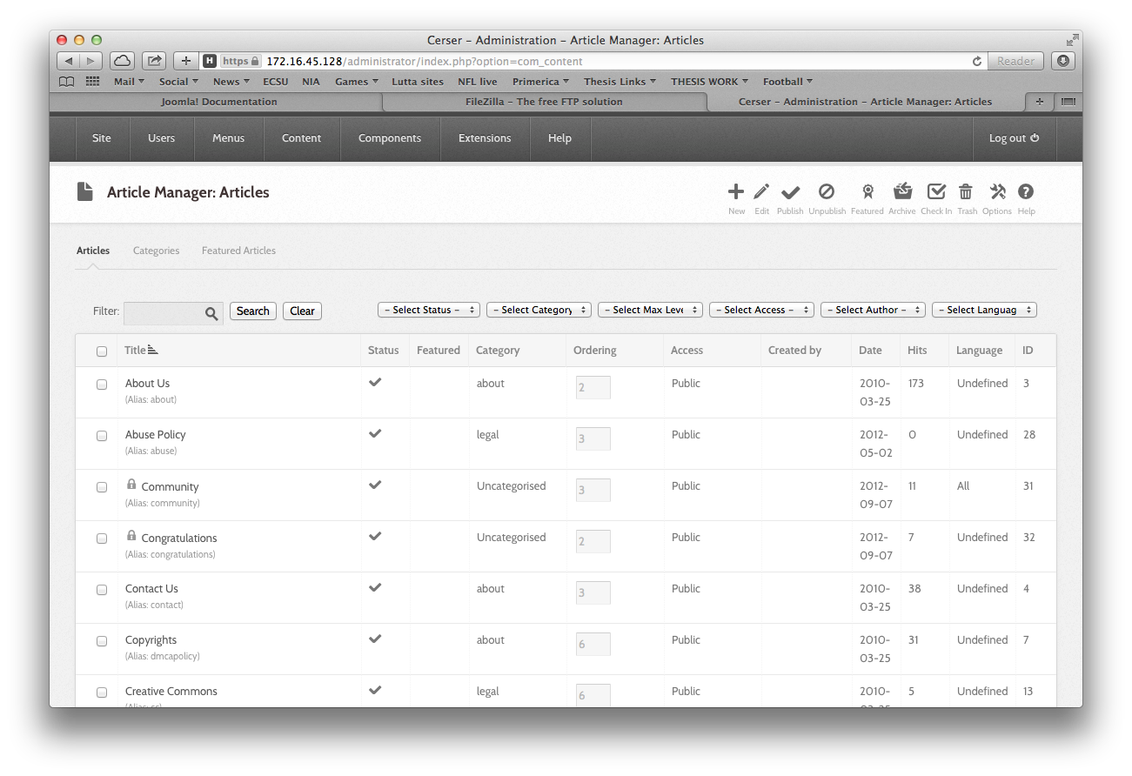

Figure 9: Image of the Back-End

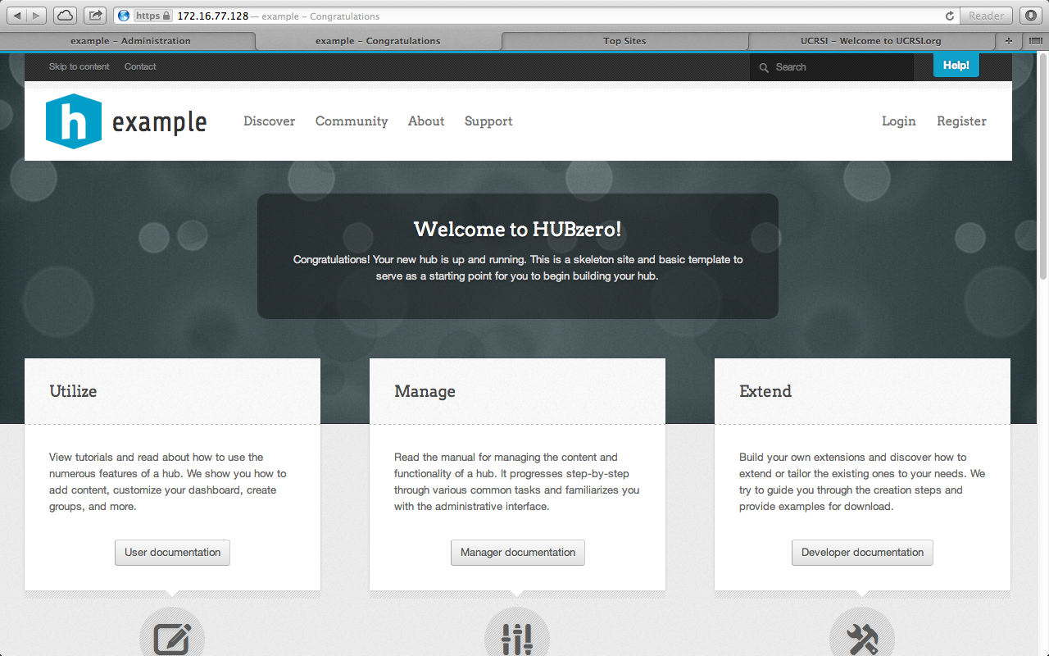

Figure 10: Image of “Front-End”

### Articles

In Joomla an Article is content consisting of HTML, most likely with links and other resources such as pictures and banners. Articles are the basic units of information in the content system. The Article Manager maintains articles, which again is in the administrator side of the Back-End in figure 11. HTML had to be learned and used to change the default content on the hub.

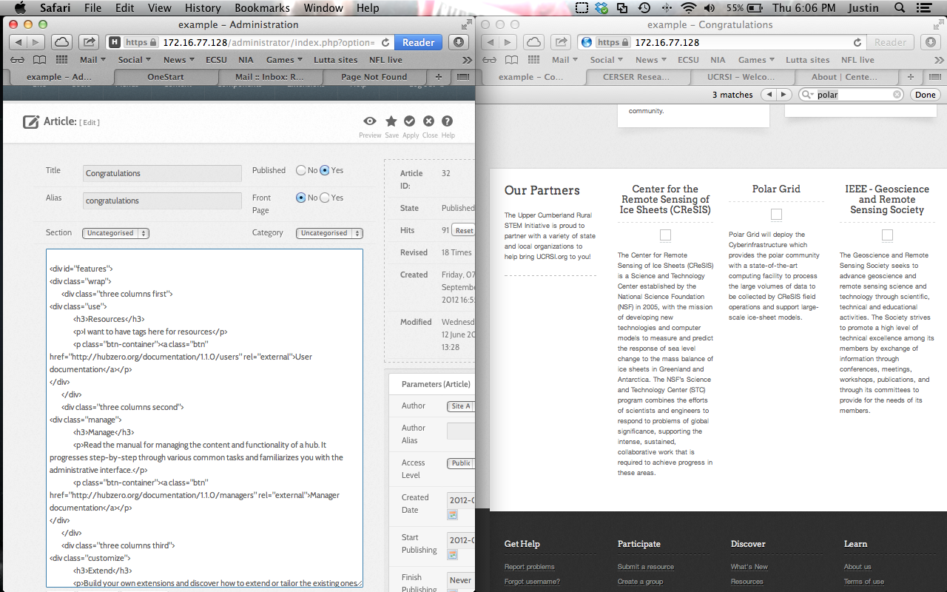

Figure 11: Utilizing the Congratulations Article to change content on the Front-End

#### Header Section: Opening Lines

The opening lines of the HTML Congratulations Article (lines 1-3) provide an opening for the connection with the CSS content.

1. //===============Congratulations Article in Hub===================
2. {xhub:include type="stylesheet" filename="pages/home.css"}

#### Creating a Section

This section of code (lines 4 - 7) sets up four different columns and starts to initiate the first column, which was given the name “Our Partners”. Partners of CERSER will be placed into each column later in this chapter.

1. <div class="support-section">
2. <div class="wrap">
3. <div class="four columns first">
4. <h2>Our Partners</h2>

#### 1st Section

Lines 8 -17 are continuing to set up the columns and announces “Elizabeth City State University is proud to partner with a variety of institutions and organizations to help bring this educational Hub to you!”

1. <p>
2. Elizabeth City State University is proud to partner with a variety of institutions and organizations to help bring this educational Hub to you!
3. </p>
4. </div>
5. <div class="four columns second third fourth">
6. <div id="partner_slides">
7. <div class="panes">
8. <div class="panes-content">
9. <div class="pane" id="partner_slides-pane1">
10. <div class="pane-wrap" id=“ecsupartners">

#### 2nd Section

Just as the class above is given a title and a description the 2nd section of the class is dedicated for CReSIS. Lines 18- 26 output the title CReSIS and a brief description.

1. <div class="three columns first">
2. <h3 style='text-align:center;'>Center for the Remote Sensing of Ice Sheets (CReSIS)</h3>
3. <p style='text-align:center;'>
4. <a href='http://www.cresis.ku.edu' rel='external'><img style='max-width:100%; max-height:100px;' src="/templates/hubbasic2012/images/logos/cresis.png" alt="" /></a>
5. </p>
6. <p class='partner_text'>
7. The Center for Remote Sensing of Ice Sheets (CReSIS) is a Science and Technology Center established by the National Science Foundation (NSF) in 2005, with the mission of developing new technologies and computer models to measure and predict the response of sea level change to the mass balance of ice sheets in Greenland and Antarctica. The NSF’s Science and Technology Center (STC) program combines the efforts of scientists and engineers to respond to problems of global significance, supporting the intense, sustained, collaborative work that is required to achieve progress in these areas.
8. </p>
9. </div>

#### 3rd Section

As section one and two were both given space for a title and a description. Section three is no different and its title is “Polar Grid”. Lines 27 – 35 are allocated to give space for a title and a description about the Polar Grid.

1. <div class="three columns second">
2. <h3 style='text-align:center;'>Polar Grid</h3>
3. <p style='text-align:center;'>
4. <a href="https://www.grss-ieee.org" rel="external"><img style='max-width:100%; max-height:100px;' src="/templates/hubbasic2012/images/logos/ieee.png" alt="" /></a>
5. </p>
6. <p class='partner_text'>
7. Polar Grid will deploy the Cyberinfrastructure which provides the polar community with a state-of-the-art computing facility to process the large volumes of data to be collected by CReSIS field operations and support large-scale ice-sheet models.
8. </p>
9. </div>

#### 4th Section

The next section (lines 36 – 44) is allocating space for the last partner on the list which is IEEE- Geoscience and Remote Sensing Society. Just like previous sections 1-3 the fourth is no different provided a title and a description.

1. <div class="three columns third">
2. <h3 style='text-align:center;'>IEEE - Geoscience and Remote Sensing Society</h3>
3. <p style='text-align:center;'>
4. <a href="http://www.tntech.edu/stem" rel="external"><img style='max-width:100%; max-height:100px; ' src="/site/media/images/stem logo.jpg" alt="" /></a>
5. </p>
6. <p class='partner_text'>
7. The Geoscience and Remote Sensing Society seeks to advance geoscience and remote sensing science and technology through scientific, technical and educational activities. The Society strives to promote a high level of technical excellence among its members by exchange of information through conferences, meetings, workshops, publications, and through its committees to provide for the needs of its members.
8. </p>
9. </div>

#### Ending Sections

The final lines (45 - 49) closes the open four columns, places the columns in the correct alignment and format.

1. <div class="clear"></div>
2. </div><!-- / .pane-wrap #ucrsipartners4 -->
3. </div><!-- / .pane #partner_slides-pane4 -->
4. </div><!-- / .panes-content -->
5. </div><!-- / .panes -->
6. </div><!-- / #pane-sliders -->
7. </div>
8. <div class="clear"></div>
9. </div>
10. </div><!-- / .inner -->

### Templates

A Joomla template is an extension that changes the look of the site. There are two types of templates utilized by Joomla. Front-end templates: which alters the way the website is presented to the users viewing the content. The Back-end template alters the way the administrative tasks are managed by using management functions provided by Joomla. For this project the Joomla template will be set to the default template, which is named Hubbasic2013. (Figure 12)

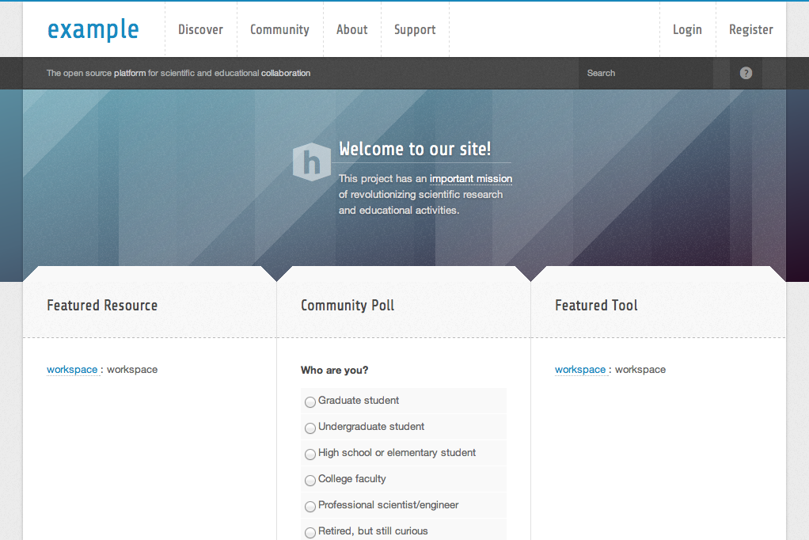

Figure 12: Basic template from new hub

## Database 1.1.2

When this project was first initiated the latest version of HUBzero that was downloadable was 1.1.2, which did not have a database extension built into HUBzero. Therefore it was necessary to create an article within Joomla with every educational file name that was available and make the file name a link. Figure 13 below shows an article created in Joomla that housed 17 file names that were links to the actual files.

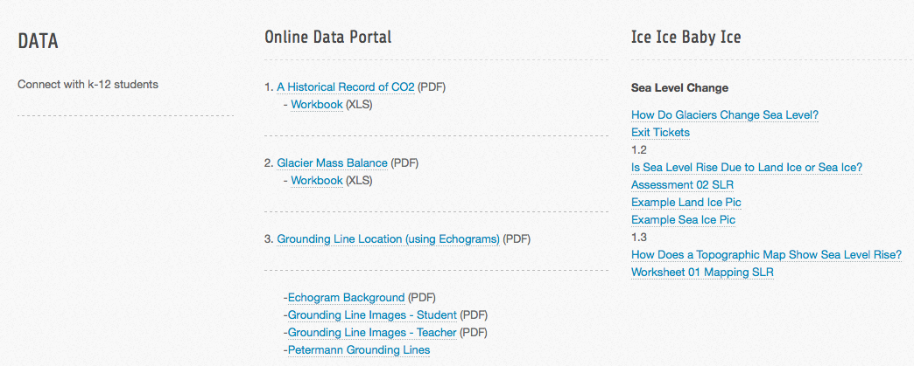

Figure 13: Article in Joomla to replace the database

This section of code (lines 56 - 62) sets up four different columns and starts to initiate the first column, which was given the name “DATA” which a description “Connect with k-12 students”

1. <div class="blocks-section wrap">
2. <div class="four columns first">
3. <h2>DATA</h2>
4. <p>
5. Connect with k-12 students
6. </p>
7. </div>

The next section (lines 63 - 65) combines the second, third and forth columns and creates only two columns and starts to initiate the first column. Next, lines 67-76 shows a list of file names along with the link location for each file.

1. <div class="four columns second third fourth">
2. <div class="two columns first">
3. <h3>Online Data Portal</h3>
4. <p>
5. <a href="/sites/default/files/images/K-12/OnlineDataPortal/Data_CO2x.pdf">A Historical Record of CO2</a> (PDF)<br />
6. <a href="/sites/default/files/images/K- 12/OnlineDataPortal/Data_CO2_Workbook.xls">Workbook</a> (XLS)</p>
7. <p>2. <a href="/sites/default/files/images/K-12/OnlineDataPortal/Data_GlacierMassBalance_Trial.pdf">Glacier Mass Balance</a> (PDF)<br />
8. <a href="/sites/default/files/images/K-12/OnlineDataPortal/Data_GlacierMassBalance_WorkbookKEY.xlsx">Workbook</a> (XLS)</p>
9. <p> 3. <a href="/sites/default/files/images/K-12/OnlineDataPortal/Data_GroundingLine_Trial.pdf">Grounding Line Location (using Echograms)</a> (PDF)</p>
10. <a href="../../sites/default/files/images/K-12/OnlineDataPortal/EchogramBackground.pdf">Echogram Background</a> (PDF)<br />
11. <a href="/sites/default/files/images/K-12/OnlineDataPortal/GroundingLine_Student.pdf">Grounding Line Images - Student</a> (PDF)<br />
12. <a href="/sites/default/files/images/K-12/OnlineDataPortal/GroundingLine_Teacher.pdf">Grounding Line Images - Teacher</a> (PDF)<br />
13. <a href="/sites/default/files/images/K-12/OnlineDataPortal/PetermannGroundingLines.kmz">Petermann Grounding Lines</a>
14. </div>

## Database 1.2

Within the newer version of HUBzero (1.2) comes default with many new features but the main feature this project takes advantage of is the database extension. The database extension allows users to create a Comma-Separated Value (CSV) file from an excel file to be uploaded and published into an interactive database.

### Creating an Excel File

The HUBzero extension is very selective when it reads data to create an interactive database. Each column has to state its title and under that cell must come the type of data that is to be inputted. (Figure 14) Also the word DATASTART must be written before the data starts. This format was used to input the links to the educational documents, the author, and the file type.

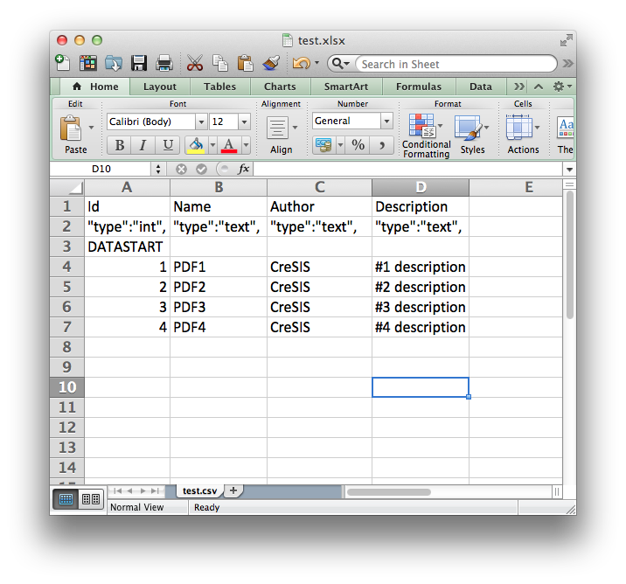

Figure 14: Image showing how data must be inputted to work correctly.

# Chapter IV Results

## Overview

Since HUBzero offers the ability to keep reports and statistics about each hub showing the total number of users, and hits, it would be beneficial to show visual results as well. The PolarEDHub also reports how many users have accessed a tool, or how many times an online seminar has been viewed and the numbers are combined to provide an overview of interesting categories. For example, users can see how many people access a particular tool, how many are located in the US, and how many are working in education or industry.

## Visual

HUBzero allows each hub to be customized by the developer. The final product of the hub has a fundamental and clean appearance. (Figure 15)

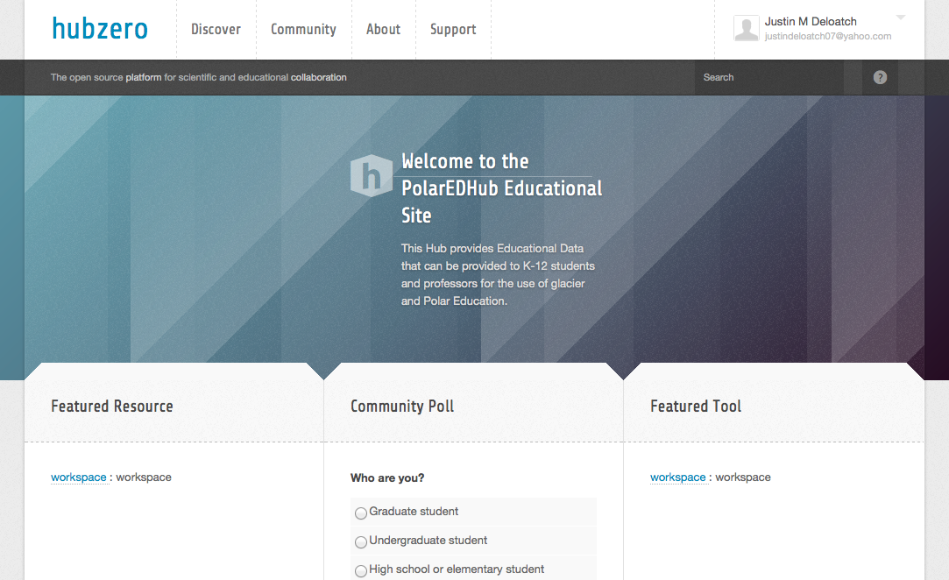Figure 15: Image of final product

## Connecting the Database to the Server using PHP

The database inside the hub needs a link to direct it to the actual file. This process happens within the CSV file that was used to create the database. Within this file, the link column offers a link to each individual PDF file that has been accessed with the PHP script in figure 16.

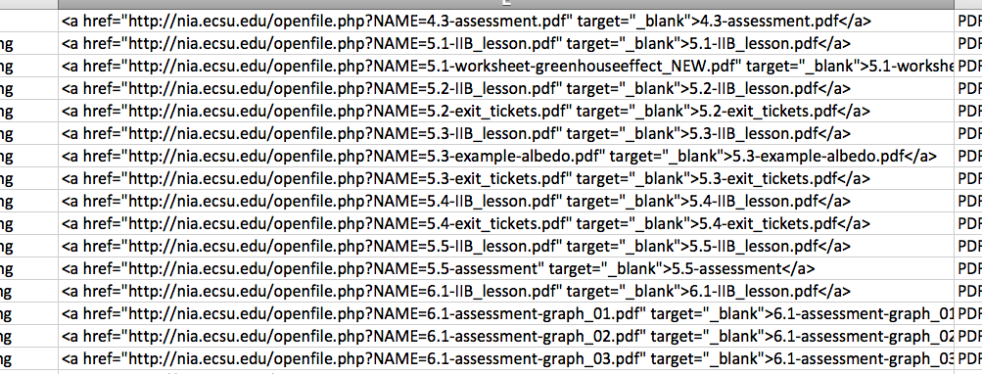

Figure 16: CSV file

The final version of the database is interactive, which means it’s searchable and sortable. Users can start typing in the search bar and the database will automatically start narrowing down the results based of the input from the user. The database can also show different number of entries depending on the users preference.

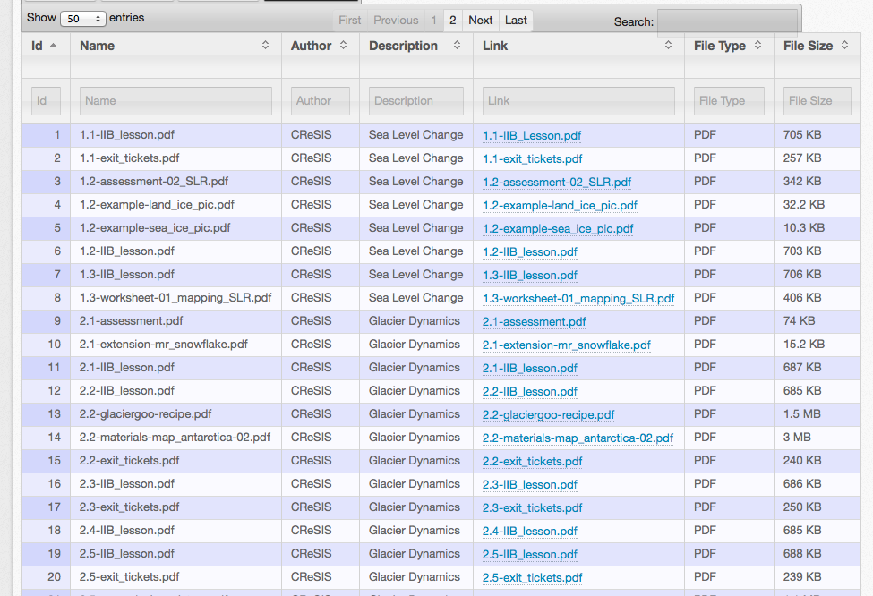

Figure 17: Database

1. <?php
2. if (!function_exists("GetSQLValueString")) {
3. function GetSQLValueString($theValue, $theType, $theDefinedValue = "", $theNotDefinedValue = "")
4. {
5. if (PHP_VERSION < 6) {
6. $theValue = get_magic_quotes_gpc() ? stripslashes($theValue) : $theValue;
7. }
9. $theValue = function_exists("mysql_real_escape_string") ? mysql_real_escape_string($theValue) : mysql_escape_string($theValue);
11. switch ($theType) {
12. case "text":
13. $theValue = ($theValue != "") ? "'" . $theValue . "'" : "NULL";
14. break;
15. case "long":
16. case "int":
17. $theValue = ($theValue != "") ? intval($theValue) : "NULL";
18. break;
19. case "double":
20. $theValue = ($theValue != "") ? doubleval($theValue) : "NULL";
21. break;
22. case "date":
23. $theValue = ($theValue != "") ? "'" . $theValue . "'" : "NULL";
24. break;
25. case "defined":
26. $theValue = ($theValue != "") ? $theDefinedValue : $theNotDefinedValue;
27. break;
28. }
29. return $theValue;
30. }}
31. if (isset($_GET['NAME'])) {
32. $FileName = $_GET['NAME'];
33. }
34. $FileName = "http://nia.ecsu.edu/IceIceBabyLessons/" . $FileName;
35. echo $FileName;
36. ini_set('auto_detect_line_endings', TRUE);
37. header("Location: $FileName");
38. ?>

## Mobility of the Hub

Due to the fact that the PolarEDHub was installed into VMware Fusion, which is a virtual machine, the hub could be copied and shared. The base installation of the hub was placed on a flash drive and shared to educators for the purposes of gathering classified feedback.

## Testing the PolarEDHub

The PolarEDHub was presented to a group of K-12 educators. After being presented with the features and use of HUBzero and also knowing that its primary use is to conduct research and collaborating, each educator was giving a survey. (figure 18) The questions were ranged from one – five as one being the lowest rating and five being the highest rating.

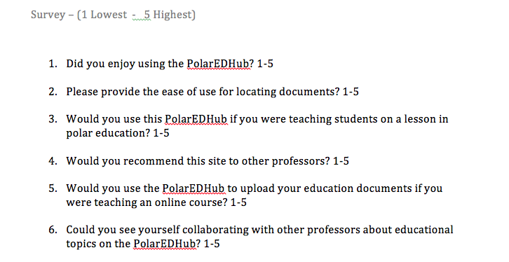

Figure 18: Image of survey

## Users Feedback

A survey was given to K-12 educators so that the PolarEdHub could be critiqued with classified feedback. The results were as follows: (Figure 19)

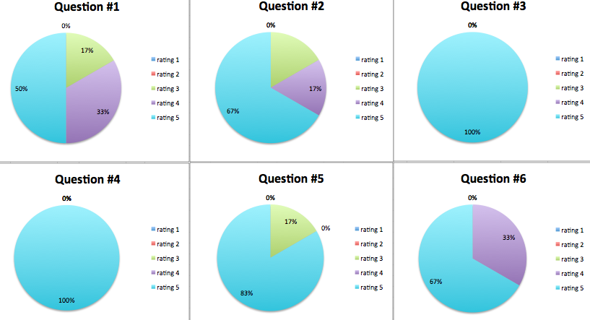Figure 19: Results

The feedback shows that the hub can be improved on its Graphical User Interface (GUI) and being more user-friendly, however the PolarEDHub shows great potential for becoming a hub that K-12 educators can utilize for the purpose of collaboration and education.

# Chapter V Discussion

## Introduction

HUBzero is a powerful, open source software platform for creating dynamic web sites that support scientific research, educational activities and training. This project has provided the cyberinfrastructure to support the process of utilizing HUBZero software for development.

The purpose of this project was to see if HUBZero could be utilized to provide K-12 educational data for students and educators. This would allow users to sign in and get access to the data and also users can upload useful data to the hub themselves without going through a web developer.

## Discussion

The results have shown that a hub was created and developed to see if HUBZero can be utilized to provide CReSIS K-12 educational icesheet data. This model met its goals in April, 2014 which were to:

* Download the educational data sets from the CReSIS website.
* Download and install HUBZero.
* Upload the educational data to the server
* Create a database that would give users a nice visual of the educational data.
* Create a php script that gave the database a direct connection to the server.
* Perform various test on the PolarEDHub

## Limitations

This paper is aimed at K-12 educators, and even developers that would like to create a hub for the purposes of education and would like to know which direction to turn in. Implementing a hub is not complicated; although to a non-experienced coder it will call for an enormous learning curve to surpass, which consumes most of the time.

The learning curve that was needed for this project was greatly affected by the amount of time needed to construct the hub. The developer was new to PHP, HTML, Joomla, and coding in java script. A team of experienced developers would have possibly reduced the production time as well as simplified the application to its most efficient sets of code. Actually for implementing a hub it is recommended that you have a collaborating team effort to construct and maintain a hub.

There is also a group called HUBzero Foundation, which is a community-based, non-profit organization that promotes the use of HUBzero and ensures ongoing sustainability of the core software. HUBzero Foundation maintains the hub for an institution for a healthy price.

## Recommendations for Future Research

Based on the outcome of this project, there are several recommendations for future research and development. The first area concerns the action of the CReSIS website maintenance and updating of new information. Since the method of this project consisted of downloading the educational files from CReSIS website as of 2013, the risk of old data comes about when CReSIS decides to add or change their documents in the future. As it has been noted, obtaining the documents was a relatively a simple task but keeping them updated as a mirror with CReSIS data is a much more complicated task. A help button should be implemented to assist users with an explanation of how to access the data and can be provided a link to directly access the database of educational files.

## Conclusions

This study concludes that it is possible to create a hub utilizing CReSIS educational data by using VMware as a base, and installing HUBzero v1.2 on it. It has also been demonstrated that a small institutions such as ECSU can develop this application with limited resources.

The results of this study illustrated that HUBzero can be developed and customized using HTML, PHP, CSS and maintain the framework of Joomla. The feedback shows that the hub can be improved on its Graphical User Interface (GUI) and being more user-friendly, however the PolarEDHub shows great potential for becoming a hub that K-12 educators can utilize for the purpose of collaboration and education.

# Bibliography

*A platform for research, collaboration and education*. (2013, 10 5). Retrieved from NEEShub: http://nees.org

Anderson, D. (2012). *BOINC Enhancement and Integration with HUBzero .* Berkeley.

Bartlett. (2005, 5 12). *New pressures for growing educational capacity.* Retrieved 1 3, 2014, from https://www.wcu.edu/ceap/houghton/readings/technology_trends.html

Brain, M. (2011, 9 12). *If the polar ice caps melted, how much would the oceans rise?* Retrieved 1 1, 2014, from HowStuffWorks: http://science.howstuffworks.com/environmental/earth/geophysics/question473.htm

*CReSIS*. (n.d.). Retrieved from CReSIS: https://www.cresis.ku.edu/about

DiGirolamo, N. E. (2012, 7 25). *Satellite Data Indicates Unprecedented Greenland Ice Sheet Surface Melt.* Retrieved 6 12, 2013, from Science, Space and Robots: http://www.sciencespacerobots.com/satellite-data-indicates-unprecedented-greenland-ice-sheet-surface-melt-72520122

*ECSU Report on Climate Change in NC/Relevant Research at ECSU.* (2008). Retrieved from http://www.northcarolina.edu/nctomorrow/ECSU_climate_change_report.pdf

FileZilla. (2013, 08 07). *FileZilla.* Retrieved 09 13, 2013, from FileZilla: https://filezilla-project.org/client_features.php

G.Klimeck, M. L. (2006, Jan). The NCN: Science, Sumulation, and Cyber Services. *IEEE Conference on Emerging Technologies* , 496-500.

Gogineni, P. (2009). CReSIS Project Summary - Draft.

Guo, Z., Singh, R., & Pierce, M. (2009). Building the PolarGrid Portal Using Web 2.0 and OpenSocial. *GCE '09: Proceedings of the 5th Grid Computing Environments Workshop.* Portland: ACM.

Hossain, M. M., & Robinson, M. G. (2011). *How to Motivate US Students to Pursue STEM.* Nevada : David Publishing.

hubzero. (n.d.). *About Us*. Retrieved 8 12, 2013, from HUBzero: https://hubzero.org/about

Huebner, E. (2013, 9 14). *Configuring and Customizing.* Retrieved 10 21, 2013, from HUBZero: http://hubzero.org/resources/1026

Institute, C. a. (n.d.). *About Us*. Retrieved 9 12, 2013, from Indiana CTSI: https://www.indianactsi.org/about/aboutus

Joolma! (n.d.). *Joomla! for Beginners*. Retrieved September 12, 2013, from Beginners - Joomla!: docs.joomla.org/Beginners

Joomla! (2013, 06 19). *Joomla! Offical Documentation.* Retrieved 09 10, 2013, from Joomla!: http://docs.joomla.org/Main_Page

Klimeck, G., McLennan, M., Brophy, S., Adams III, G., & Lundstrom, M. (2008). *nanoHUB.org: Advancing Education and Research in Nanotechnology.* Computing in Science and Engineering.

McLennan, M. *The Hub Concept for Scientific Collaboration.* Rosen Center for Advanced Computing.

McLennan, M. (n.d.). *The Rappture Toolkit*. Retrieved from http://www.rappture.org

nanoHUB. (2013, 10 15). *nanoHUB*. Retrieved from Online Simulation and More for Nanotechnology: http://nanohub.org

Schaeffer, U. (2012, 3 5). *Knowledge is power: why education matters.* Retrieved 8 12, 2013, from DW: http://www.dw.de/knowledge-is-power-why-education-matters/a-15880356

VMware. (2013, 10 17). *Company*. Retrieved from VMware: www.vmware.com

w3schools.com. (n.d.). *HTML*. Retrieved 10 12, 2013, from w3schools: http://www.w3schools.com/html/html_intro.asp

*Why STEM?* (n.d.). Retrieved 06 2013, from Change The Equation: http://changetheequation.org/why-stem

XSEDE. (2012, 9 10). *Education Outreach*. Retrieved 5 12, 2013, from XSEDE: https://www.xsede.org/education-outreach-blog/-/blogs/386663

# Appendix A – Code from “Congratulations Article” and “openfile.php”

1. //===============Congratulations Article in Hub===================
2. {xhub:include type="stylesheet" filename="pages/home.css"}
3. <div class="support-section">
4. <div class="wrap">
5. <div class="four columns first">
6. <h2>Our Partners</h2>
7. <p>
8. Elizabeth City State University is proud to partner with a variety institutions and organizations to help bring this educational Hub to you!
9. </p>
10. </div>
11. <div class="four columns second third fourth">
12. <div id="partner_slides">
13. <div class="panes">
14. <div class="panes-content">
15. <div class="pane" id="partner_slides-pane1">
16. <div class="pane-wrap" id=“ecsupartners">
17. <div class="three columns first">
18. <h3 style='text-align:center;'>Center for the Remote Sensing of Ice Sheets (CReSIS)</h3>
19. <p style='text-align:center;'>
20. <a href='http://www.cresis.ku.edu' rel='external'><img style='max-width:100%; max-height:100px;' src="/templates/hubbasic2012/images/logos/cresis.png" alt="" /></a>
21. </p>
22. <p class='partner_text'>
23. The Center for Remote Sensing of Ice Sheets (CReSIS) is a Science and Technology Center established by the National Science Foundation (NSF) in 2005, with the mission of developing new technologies and computer models to measure and predict the response of sea level change to the mass balance of ice sheets in Greenland and Antarctica. The NSF’s Science and Technology Center (STC) program combines the efforts of scientists and engineers to respond to problems of global significance, supporting the intense, sustained, collaborative work that is required to achieve progress in these areas.
24. </p>
25. </div>
26. <div class="three columns second">
27. <h3 style='text-align:center;'>Polar Grid</h3>
28. <p style='text-align:center;'>
29. <a href="https://www.grss-ieee.org" rel="external"><img style='max-width:100%; max-height:100px;' src="/templates/hubbasic2012/images/logos/ieee.png" alt="" /></a>
30. </p>
31. <p class='partner_text'>
32. Polar Grid will deploy the Cyberinfrastructure which provides the polar community with a state-of-the-art computing facility to process the large volumes of data to be collected by CReSIS field operations and support large-scale ice-sheet models.
33. </p>
34. </div>
35. <div class="three columns third">
36. <h3 style='text-align:center;'>IEEE - Geoscience and Remote Sensing Society</h3>
37. <p style='text-align:center;'>
38. <a href="http://www.tntech.edu/stem" rel="external"><img style='max-width:100%; max-height:100px; ' src="/site/media/images/stem logo.jpg" alt="" /></a>
39. </p>
40. <p class='partner_text'>
41. The Geoscience and Remote Sensing Society seeks to advance geoscience and remote sensing science and technology through scientific, technical and educational activities. The Society strives to promote a high level of technical excellence among its members by exchange of information through conferences, meetings, workshops, publications, and through its committees to provide for the needs of its members.
42. </p>
43. </div>
44. <div class="clear"></div> </div><!-- / .pane-wrap #ucrsipartners4 -->
45. </div><!-- / .pane #partner_slides-pane4 -->
46. </div><!-- / .panes-content -->
47. </div><!-- / .panes -->
48. </div><!-- / #pane-sliders -->
49. </div>
50. <div class="clear"></div>
51. </div>
52. </div><!-- / .inner -->
53. //==========
54. <div class="blocks-section wrap">
55. <div class="four columns first">
56. <h2>DATA</h2>
57. <p>
58. Connect with k-12 students
59. </p>
60. </div>
61. <div class="four columns second third fourth">
62. <div class="two columns first">
63. <h3>Online Data Portal</h3>
64. <p>
65. <a href="/sites/default/files/images/K-12/OnlineDataPortal/Data_CO2x.pdf">A Historical Record of CO2</a> (PDF)<br />
66. <a href="/sites/default/files/images/K- 12/OnlineDataPortal/Data_CO2_Workbook.xls">Workbook</a> (XLS)</p>
67. <p>2. <a href="/sites/default/files/images/K-12/OnlineDataPortal/Data_GlacierMassBalance_Trial.pdf">Glacier Mass Balance</a> (PDF)<br />
68. <a href="/sites/default/files/images/K-12/OnlineDataPortal/Data_GlacierMassBalance_WorkbookKEY.xlsx">Workbook</a> (XLS)</p>
69. <p> 3. <a href="/sites/default/files/images/K-12/OnlineDataPortal/Data_GroundingLine_Trial.pdf">Grounding Line Location (using Echograms)</a> (PDF)</p>
70. <a href="../../sites/default/files/images/K-12/OnlineDataPortal/EchogramBackground.pdf">Echogram Background</a> (PDF)<br />
71. <a href="/sites/default/files/images/K-12/OnlineDataPortal/GroundingLine_Student.pdf">Grounding Line Images - Student</a> (PDF)<br />
72. <a href="/sites/default/files/images/K-12/OnlineDataPortal/GroundingLine_Teacher.pdf">Grounding Line Images - Teacher</a> (PDF)<br />
73. <a href="/sites/default/files/images/K-12/OnlineDataPortal/PetermannGroundingLines.kmz">Petermann Grounding Lines</a>
74. </div>
75. <div class="two columns second">
76. <h3>Ice Ice Baby Ice</h3>
77. <p>
78. <h4> Sea Level Change </h4>
79. <li class="edu-lessons-list">
80. <a href="/sites/default/files/2011_Ice_Ice_Baby/1.1-IIB_lesson.pdf">How Do Glaciers Change Sea Level?</a></li>
81. <li class="edu-lessons-list">
82. <a href="/sites/default/files/2011_Ice_Ice_Baby/1.1-exit_tickets.pdf">Exit Tickets</a></li>
83. </ul>
84. <div class="edu-sub-section">
85. 1.2</div>
86. <ul class="edu-lessons-ul">
87. <li class="edu-lessons-list">
88. <a href="/sites/default/files/2011_Ice_Ice_Baby/1.2-IIB_lesson.pdf">Is Sea Level Rise Due to Land Ice or Sea Ice?</a></li>
89. <li class="edu-lessons-list">
90. <a href="/sites/default/files/2011_Ice_Ice_Baby/1.2-assessment-02_SLR.pdf">Assessment 02 SLR</a></li>
91. <li class="edu-lessons-list">
92. <a href="/sites/default/files/2011_Ice_Ice_Baby/1.2-example-land_ice_pic.pdf">Example Land Ice Pic</a></li>
93. <li class="edu-lessons-list">
94. <a href="/sites/default/files/2011_Ice_Ice_Baby/1.2-example-sea_ice_pic.pdf">Example Sea Ice Pic</a></li>
95. </ul>
96. <div class="edu-sub-section">
97. 1.3</div>
98. <ul class="edu-lessons-ul">
99. <li class="edu-lessons-list">
100. <a href="/sites/default/files/2011_Ice_Ice_Baby/1.3-IIB_lesson.pdf">How Does a Topographic Map Show Sea Level Rise?</a></li>
101. <li class="edu-lessons-list">
102. <a href="/sites/default/files/2011_Ice_Ice_Baby/1.3-worksheet-01_mapping_SLR.pdf">Worksheet 01 Mapping SLR</a></li>
103. </ul>
104. </p>
105. </div>
106. <div class="clear"></div>
107. <div class="two columns first">
108. <h3>Questions &amp; Answers</h3>
109. <p>
110. This is where you can <a rel="external" href="http://hubzero.org/answers">ask questions</a>, get answers, and help others in the community.
111. </p>
112. </div>
113. <div class="two columns second">
114. <h3>Forums</h3>
115. <p>
116. A place for you to start a <a rel="external" href="http://hubzero.org/forum">discussion</a> or find out what everyone is talking about.
117. </p>
118. </div>
119. <div class="clear"></div>
120. </div>
121. <div class="clear"></div>
122. </div><!-- / .inner -->
123. //==========openfie.php===============================
124. <?php
125. if (!function_exists("GetSQLValueString")) {
126. function GetSQLValueString($theValue, $theType, $theDefinedValue = "", $theNotDefinedValue = "")
127. {
128. if (PHP_VERSION < 6) {
129. $theValue = get_magic_quotes_gpc() ? stripslashes($theValue) : $theValue;
130. }
132. $theValue = function_exists("mysql_real_escape_string") ? mysql_real_escape_string($theValue) : mysql_escape_string($theValue);
134. switch ($theType) {
135. case "text":
136. $theValue = ($theValue != "") ? "'" . $theValue . "'" : "NULL";
137. break;
138. case "long":
139. case "int":
140. $theValue = ($theValue != "") ? intval($theValue) : "NULL";
141. break;
142. case "double":
143. $theValue = ($theValue != "") ? doubleval($theValue) : "NULL";
144. break;
145. case "date":
146. $theValue = ($theValue != "") ? "'" . $theValue . "'" : "NULL";
147. break;
148. case "defined":
149. $theValue = ($theValue != "") ? $theDefinedValue : $theNotDefinedValue;
150. break;
151. }
152. return $theValue;
153. }}
154. if (isset($_GET['NAME'])) {
155. $FileName = $_GET['NAME'];
156. }
157. $FileName = "http://nia.ecsu.edu/IceIceBabyLessons/" . $FileName;
158. echo $FileName;
159. ini_set('auto_detect_line_endings', TRUE);
160. header("Location: $FileName");
161. ?>